**E COMMERCE APP CODES AND SCREEN SHOTS**

**FRONTEND;**

import React, { useEffect, useState } from "react";

import { View, Text, FlatList, Image, TouchableOpacity, StyleSheet } from "react-native";

import axios from "axios";

export default function HomeScreen() {

  const [products, setProducts] = useState([]);

  // fetch data from backend

  useEffect(() => {

    axios

      .get("http://localhost:3000/products")

      .then((res) => setProducts(res.data))

      .catch((err) => console.log(err));

  }, []);

  return (

    <View style={styles.container}>

      <Text style={styles.header}>🛍️ Product List</Text>

      <FlatList

        data={products}

        keyExtractor={(item) => item.id.toString()}

        renderItem={({ item }) => (

          <TouchableOpacity style={styles.card}>

            <Image source={{ uri: item.image_url }} style={styles.image} />

            <View>

              <Text style={styles.name}>{item.name}</Text>

              <Text style={styles.price}>${item.price}</Text>

            </View>

          </TouchableOpacity>

        )}

      />

    </View>

  );

}

const styles = StyleSheet.create({

  container: {

    flex: 1,

    padding: 10,

    backgroundColor: "#fff",

  },

  header: {

    fontSize: 24,

    fontWeight: "bold",

    marginBottom: 10,

  },

  card: {

    flexDirection: "row",

    alignItems: "center",

    marginBottom: 10,

    backgroundColor: "#f9f9f9",

    padding: 10,

    borderRadius: 10,

  },

  image: {

    width: 80,

    height: 80,

    borderRadius: 10,

    marginRight: 10,

  },

  name: {

    fontSize: 18,

    fontWeight: "600",

  },

  price: {

    fontSize: 16,

    color: "green",

  },

});

**BACKEND CODE;**

const express = require('express');

const cors = require('cors');

const mysql = require('mysql2');

const app = express();

app.use(cors());

app.use(express.json());

// ✅ Connect to MySQL

const connection = mysql.createConnection({

  host: 'localhost',

  user: 'root',

  password: '', // leave empty if default

  database: 'ecommerce'

});

connection.connect(err => {

  if (err) {

    console.error('❌ MySQL connection error:', err);

  } else {

    console.log('✅ Connected to MySQL database');

  }

});

// ✅ Route to get all products

app.get('/products', (req, res) => {

  connection.query('SELECT * FROM products', (err, results) => {

    if (err) {

      console.error(err);

      res.status(500).json({ error: 'Database error' });

    } else {

      res.json(results);

    }

  });

});

app.listen(3000, () => {

  console.log('🚀 Server running on port 3000');

});

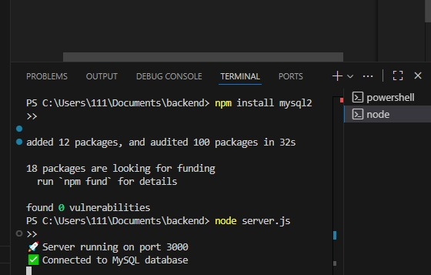

**APP DISPLAY;**

